# Practical 1

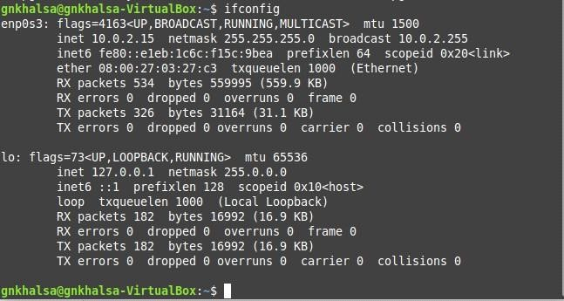

Steps to configure DHCP Server, Configure NFS Server to share directories on your network, Configure NFS Client (Ubuntu and Windows OS)

**Step1:** In your Ubuntu 16.04, open up a terminal and input the following command to install dhcp server.

## sudo apt-get install isc-dhcp-server

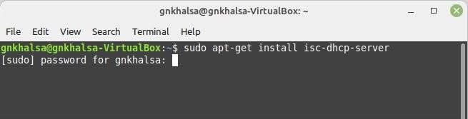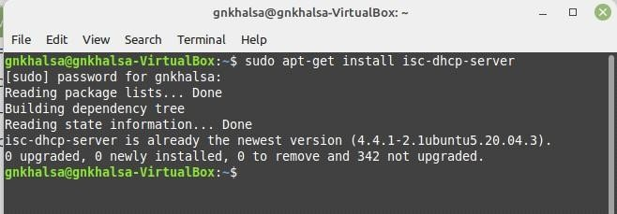

**Step2:** Once the installation has been done, make sure the network settings of your virtual machine are setto bridged network.

**Step3:** In the terminal, type inconfig to verify as to weather an ip address has been assigned to your virtual machine.

**Step4:** Next we need to configure our installed dhcp server to it serve ip address to connecting clients. Follows the following configuration.



**Step5:** Look for the section which says "A slightly different configuration for internal subnel".

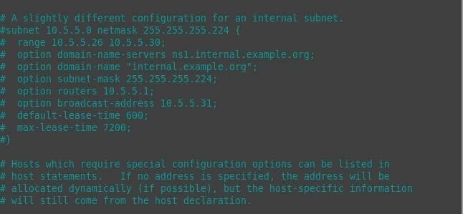

**Step6:** Now start by config the subnet line. Set the first ip address to the start of your network range.(The ip address you received in the output of ifconfig be use dto calculated it. Here the ip address was 192.168.0.10 and hence network ip is 192.168.0.0).

**Step7:** Set the net mask to 255.255.255.0 (This can be done by pressing ctrl+\ which will open a replace prompt wher you will have to type the original net mask which here was 255.255.255.224 and press enter the it will ask what it should be replaced with, then type 255.255.255.0, then press enter).

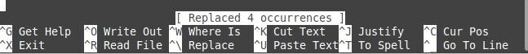

**Step8:** In range set a range of ip address you would like server to serve. Here it is set to server 20 addresses ranging from 10.5.5.10 to 10.5.5.30 (For changing the range do the same by replacing the whole range section by typing "range 10.5.5.10 10.5.5.30" in replace it with prompt)

**Note:** The range for me was 10.5.5.26 10.5.5.30, for your pc/system it might be differnt so change accordingly.

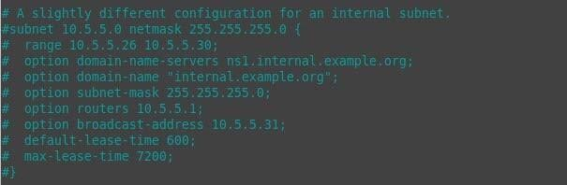

**Step9:** Configure the routes line to be the default gateway.

**Step10:** Save the file by exiting it "ctrl+X", then in the prompt enter y and press enter or just press enter.

**Step11:** Now we have installed and configures our dhcp server. Let's start our dhcp server by using the following command.

## sudo /etc/init.d/isc-dhcp-server start

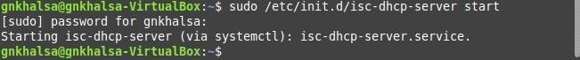

**Step12:** To cross verify that help the ip address is actually served from the dhcp server go back to Ubuntu where the dhcp server has been configured and type in

**cat /var/lib/dhcp/dhcpd.leases**

